Technical documentation

Game frame
The game frame is a crucial part of the game user interface design because it creates the window in which the user will be able to interact in.
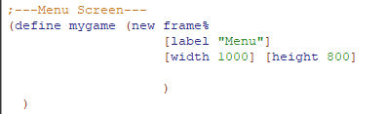
This is the frame for our menu page where the user will be able to select start or exit game whenever he opens the game file for the first time. Here you can set the size of the window by adjusting the width and height of the window to your preferred size.

Buttons
We have used a lot of buttons in creating our game, here is an example of one of the buttons that we have used.
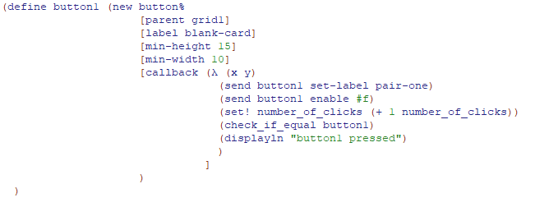
Buttons in racket can have their height and width adjusted as well as frames and can hold images as their labels which we used for our game, you can also have call back functions that will perform certain actions based on what you have coded the button to perform for example in our case we have used this button to change the image of the button when clicked.
Another example of a button we have implemented is the frame change button which allows us to change from one frame to another with the click of a button as shown in the code below.
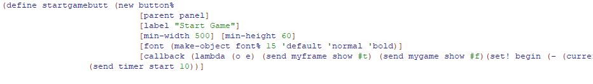
We have also implemented an exit button that will close the current opened window when clicked by the user.
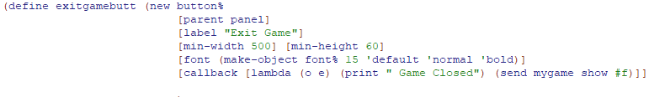
Another button that we have used is the stop button which will stop the timer from counting and lock the current seconds in place for the user to see in a new window that will be created upon clicking the “Stop” button.
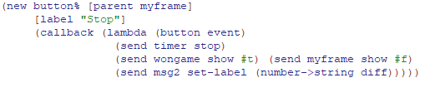

Read-bitmap
The read bitmap racket function allows image file paths to be defined in racket to be later used in other areas such as adding them to buttons or frames.
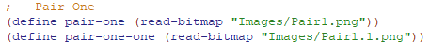

Horizontal-panel
The horizontal panel allows us to create rows for our buttons so we can have multiple rows of buttons side by side in a grid like order that will look better then random buttons dotted all around the place.
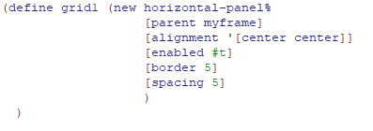
The horizontal panel allows the user to create a gap between the border and the content that is being added or you can create spacing which will separate all your objects within the grid so they are not stuck to each other.

Check if equal
The check if equal function will check if the mouse has clicked a button and if a button has been clicked it will check for a second button click and if that has happened then it will go through all the buttons and check if the two buttons clicked equal to the code that has been written in the function. For example if you click button 1 and then click button 1 again nothing will happen, but if you click button 2 the function will find a match and execute a call back that will keep the cards face side up, however if the two button do not match for examples buttons 2 and 13 then the program will execute another call back that will flip the cards to their initial image and keep repeating until all cards have been flipped up.
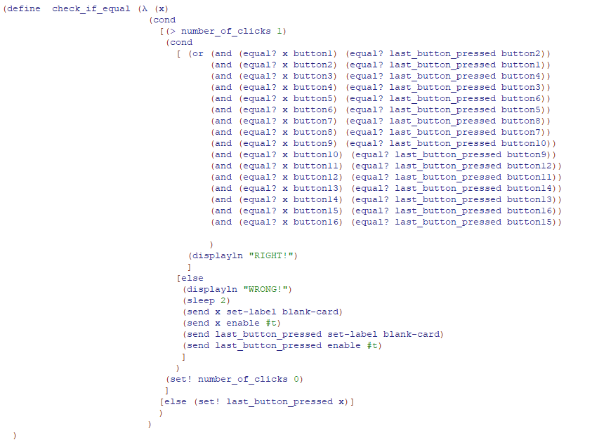

Timer
To make the timer we had to have two definitions begin and diff which will keep track of which second on the clock the timer will start which in our case it stars from 0 and the difference will be the time that has gone by from the beginning 0 seconds.
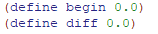
The timer call back will always be executed when the star game button has been pressed by the user and will begin a counter that will be displayed on the game frame to show the user how well they are doing in terms of the completion time.
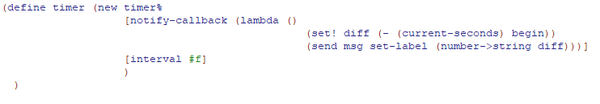

Messages
The messages have been used in our game to give some indication to the user as to what some of the things they are looking at mean for example upon clicking the stop button the user will see the message winner on the frame and “Your time is:” so they know that they are looking at the time they have scored during their attempt at completing the game.
